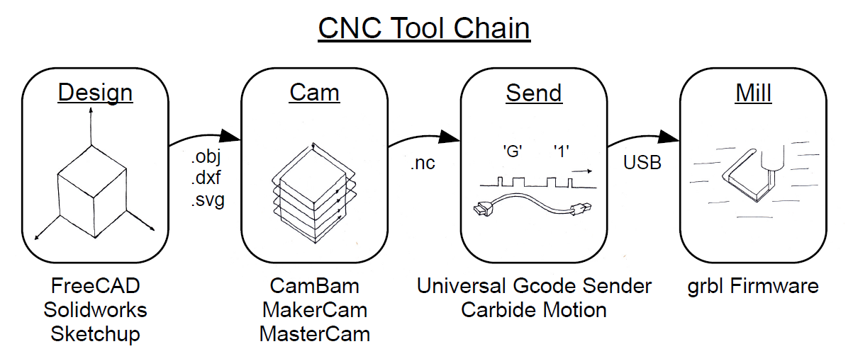

**What is CAD/CAM software?**

* CAD/CAM stands for computer-aided design and computer-aided manufacturing.

**What is CAD/CAM used for?**

* CAD/CAM applications are used to both design 2D/3D products and program manufacturing processes, specifically, CNC machining.
* CAM software uses the models and assemblies created in CAD software to generate tool paths that drive machine tools to turn designs into physical parts.

**What is G Code?**

* G Code is a programming language for computer numerical control ([CNC](https://searcherp.techtarget.com/definition/computer-numerical-control-CNC)) in computer-aided design and manufacturing ([CAD/CAM](https://whatis.techtarget.com/definition/CAD-CAM-computer-aided-design-computer-aided-manufacturing)).
* It provides metric-based numeric control of CAM-controlled equipment such as CNC milling machines.
* The code used in G-code and other CNC code tells the computer that controls the motors of the manufacturing equipment how far to move and at what speed.

**How Does G-code Work?**

* G-code is created as the output from sophisticated CAD/CAM (computer aided design/computer aided manufacturing) software.
* Each line of code tells the machine to perform one discrete action, including position, speed, rotation, etc. Shapes are made by stringing together point-by-point sets of instructions. Even simple parts can require hundreds or thousands of lines of code, and ultimately they must all work flawlessly together to achieve the desired result.

**Example for G Code:**

**extension for g code file is .nc**

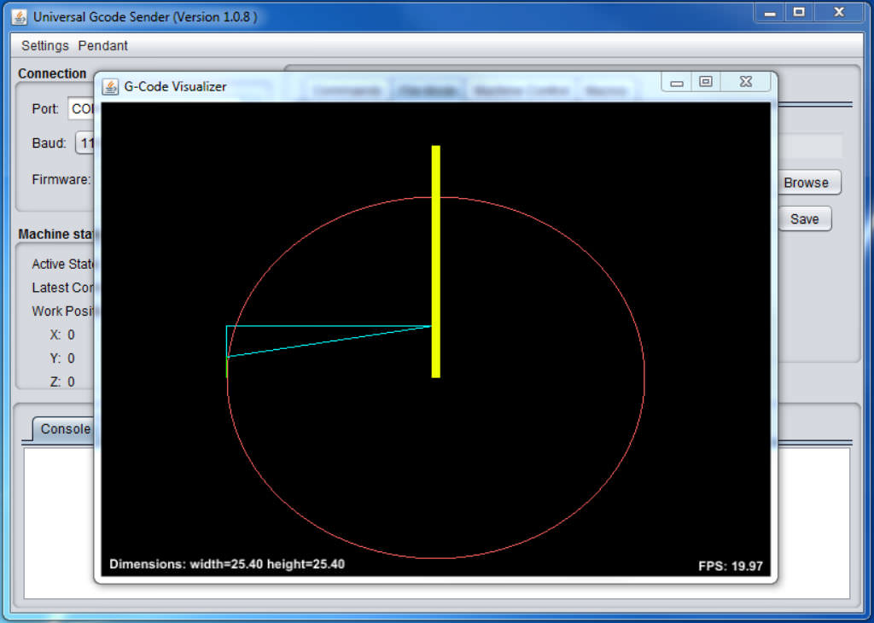

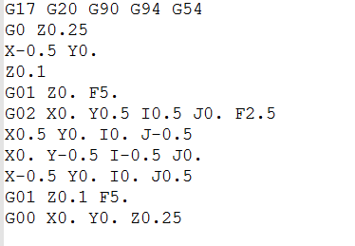

**G17 G20 G90 G94 G54**

|  |  |  |
| --- | --- | --- |
| **G17** | XY plane selection |  |
| **G20** | Programming in inches |  |
| **G90** | Absolute Coordinates | Indicates that absolute motion will be used to  perform subsequent motion commands |
| **G94** | F/minute | Tells the machine control to feed in units per minute |
| **G54** | Local coordinate system | Specify the work offset to be a local coordinate system |

**G0 Z0.25**

|  |  |  |
| --- | --- | --- |
| **G0** | Rapid Move | Moves one or more of the 05 axes, at the rapid speed, to a specified location |

**X-0.5 Y0.**

**Z0.1**

**G01 Z0. F5.**

|  |  |  |
| --- | --- | --- |
| **G01** | Linear Cutting Move | Moves one or more of the axes 06 along a straight line, at the cutting speed, to a specified location |

**G02 X0. Y0.5 I0.5 J0. F2.5**

|  |  |  |
| --- | --- | --- |
| **G02** | Clockwise Arc | Moves two of the axes, at the *or* cutting speed, along an arc a clockwise direction to a specified location |

**X0.5 Y0. I0. J-0.5**

**X0. Y-0.5 I-0.5 J0.**

**X-0.5 Y0. I0. J0.5**

**G01 Z0.1 F5.**

**G00 X0. Y0. Z0.25**